# Implement Hidden Markov Model to predict the Part of the Speech Tagging:

**Tool**: Python

**Libraries Used**: pandas, tabulate

**Sample Problem**: Implement a POS Tagger using Hidden Markov Models

**Input Type:** Implement Observed States, Hidden States, Emission Probabilities, Transition Probabilities, Input Probabilities

**Output Type**: Sequences and Probability Scores

**Implementation:**

import pandas as pd

from tabulate import tabulate

# given states - what are the possible combinations

# total number of combinations is (number of possible states)^(sequence length)

def generate_sequence(states, sequence_length):

all_sequences = []

nodes = []

depth = sequence_length

def gen_seq_recur(states, nodes, depth):

if depth == 0:

#print nodes

all_sequences.append(nodes)

else:

for state in states:

temp_nodes = list(nodes)

temp_nodes.append(state)

gen_seq_recur(states,temp_nodes,depth-1)

gen_seq_recur(states,[],depth)

return all_sequences

def score_sequences(sequences,initial_probs,transition_probs,emission_probs,obs):

best_score = -1

best_sequence = None

sequence_scores = []

for seq in sequences:

total_score = 1

first = True

for i in range(len(seq)):

state_score = 1

# compute transitition probability score

if first == True:

state_score *= initial_probs[seq[i]]

# reset first flag

first = False

else:

state_score *= transition_probs[seq[i] + "|" + seq[i-1]]

# add to emission probability score

state_score *= emission_probs[obs[i] + "|" + seq[i]]

# update the total score

#print state_score

total_score *= state_score

sequence_scores.append(total_score)

return sequence_scores

# pretty printing our distributions

def pretty_print_probs(distribs):

print(distribs)

rows = set()

cols = set()

for val in distribs.keys():

temp = val.split("|")

rows.add(temp[0])

cols.add(temp[1])

rows = list(rows)

cols = list(cols)

df = []

for i in range(len(rows)):

temp = []

for j in range(len(cols)):

temp.append(distribs[rows[i]+"|"+cols[j]])

df.append(temp)

I = pd.Index(rows, name="rows")

C = pd.Index(cols, name="cols")

df = pd.DataFrame(data=df,index=I, columns=C)

print (tabulate(df, headers='keys', tablefmt='psql'))

def initializeSequences(_obs):

# Generate list of sequences

seqLen = len(_obs)

seqs = generate_sequence(states, seqLen)

# Score sequencessc

seq_scores = score_sequences(seqs,initial_probs,transition_probs,emission_probs,obs)

return (seqLen,seqs,seq_scores)

states = ['Noun','Verb','Determiner']

initial_probs = {'Noun':0.9,'Verb':0.05,'Determiner':0.05}

transition_probs = {'Noun|Noun':0.1,'Noun|Verb':0.1,'Noun|Determiner':0.8,

'Verb|Noun':0.8,'Verb|Verb':0.1,'Verb|Determiner':0.1,

'Determiner|Noun':0.1,'Determiner|Verb':0.8,'Determiner|Determiner':0.1}

emission_probs = {'Vimal|Noun':0.9,'taught|Noun':0.05,'the|Noun':0.05,'class|Noun':0.9,\

'Vimal|Verb':0.05,'taught|Verb':0.9,'the|Verb':0.05,'class|Verb':0.05,\

'Vimal|Determiner':0.05,'taught|Determiner':0.05,'the|Determiner':0.9,'class|Determiner':0.05}

print("Initial Distributions")

print(initial_probs)

print("\nTransition Probabilities")

pretty_print_probs(transition_probs)

print("\nEmission Probabilities")

pretty_print_probs(emission_probs)

obs = ['Vimal','taught','the','class']

# print results

print("\nScores")

# Generate list of sequences

sequence_length,sequences,sequence_scores = initializeSequences(obs)

# Display sequence scores

for i in range(len(sequences)):

print("Sequence:%-60s Score:%0.6f" % (sequences[i],sequence_scores[i]))

# Display the winning score

print("\n Best Sequence")

print(sequences[sequence_scores.index(max(sequence_scores))],max(sequence_scores))

**Output:**

Scores

Sequence:['Noun', 'Noun', 'Noun', 'Noun'] Score:0.000002

Sequence:['Noun', 'Noun', 'Noun', 'Verb'] Score:0.000001

Sequence:['Noun', 'Noun', 'Noun', 'Determiner'] Score:0.000000

Sequence:['Noun', 'Noun', 'Verb', 'Noun'] Score:0.000015

Sequence:['Noun', 'Noun', 'Verb', 'Verb'] Score:0.000001

Sequence:['Noun', 'Noun', 'Verb', 'Determiner'] Score:0.000006

Sequence:['Noun', 'Noun', 'Determiner', 'Noun'] Score:0.000262

Sequence:['Noun', 'Noun', 'Determiner', 'Verb'] Score:0.000002

Sequence:['Noun', 'Noun', 'Determiner', 'Determiner'] Score:0.000002

Sequence:['Noun', 'Verb', 'Noun', 'Noun'] Score:0.000262

Sequence:['Noun', 'Verb', 'Noun', 'Verb'] Score:0.000117

Sequence:['Noun', 'Verb', 'Noun', 'Determiner'] Score:0.000015

Sequence:['Noun', 'Verb', 'Verb', 'Noun'] Score:0.000262

Sequence:['Noun', 'Verb', 'Verb', 'Verb'] Score:0.000015

Sequence:['Noun', 'Verb', 'Verb', 'Determiner'] Score:0.000117

Sequence:['Noun', 'Verb', 'Determiner', 'Noun'] Score:0.302331

Sequence:['Noun', 'Verb', 'Determiner', 'Verb'] Score:0.002100

Sequence:['Noun', 'Verb', 'Determiner', 'Determiner'] Score:0.002100

Sequence:['Noun', 'Determiner', 'Noun', 'Noun'] Score:0.000015

Sequence:['Noun', 'Determiner', 'Noun', 'Verb'] Score:0.000006

Sequence:['Noun', 'Determiner', 'Noun', 'Determiner'] Score:0.000001

Sequence:['Noun', 'Determiner', 'Verb', 'Noun'] Score:0.000002

Sequence:['Noun', 'Determiner', 'Verb', 'Verb'] Score:0.000000

Sequence:['Noun', 'Determiner', 'Verb', 'Determiner'] Score:0.000001

Sequence:['Noun', 'Determiner', 'Determiner', 'Noun'] Score:0.000262

Sequence:['Noun', 'Determiner', 'Determiner', 'Verb'] Score:0.000002

Sequence:['Noun', 'Determiner', 'Determiner', 'Determiner'] Score:0.000002

Sequence:['Verb', 'Noun', 'Noun', 'Noun'] Score:0.000000

Sequence:['Verb', 'Noun', 'Noun', 'Verb'] Score:0.000000

Sequence:['Verb', 'Noun', 'Noun', 'Determiner'] Score:0.000000

Sequence:['Verb', 'Noun', 'Verb', 'Noun'] Score:0.000000

Sequence:['Verb', 'Noun', 'Verb', 'Verb'] Score:0.000000

Sequence:['Verb', 'Noun', 'Verb', 'Determiner'] Score:0.000000

Sequence:['Verb', 'Noun', 'Determiner', 'Noun'] Score:0.000001

Sequence:['Verb', 'Noun', 'Determiner', 'Verb'] Score:0.000000

Sequence:['Verb', 'Noun', 'Determiner', 'Determiner'] Score:0.000000

Sequence:['Verb', 'Verb', 'Noun', 'Noun'] Score:0.000000

Sequence:['Verb', 'Verb', 'Noun', 'Verb'] Score:0.000000

Sequence:['Verb', 'Verb', 'Noun', 'Determiner'] Score:0.000000

Sequence:['Verb', 'Verb', 'Verb', 'Noun'] Score:0.000000

Sequence:['Verb', 'Verb', 'Verb', 'Verb'] Score:0.000000

Sequence:['Verb', 'Verb', 'Verb', 'Determiner'] Score:0.000000

Sequence:['Verb', 'Verb', 'Determiner', 'Noun'] Score:0.000117

Sequence:['Verb', 'Verb', 'Determiner', 'Verb'] Score:0.000001

Sequence:['Verb', 'Verb', 'Determiner', 'Determiner'] Score:0.000001

Sequence:['Verb', 'Determiner', 'Noun', 'Noun'] Score:0.000000

Sequence:['Verb', 'Determiner', 'Noun', 'Verb'] Score:0.000000

Sequence:['Verb', 'Determiner', 'Noun', 'Determiner'] Score:0.000000

Sequence:['Verb', 'Determiner', 'Verb', 'Noun'] Score:0.000000

Sequence:['Verb', 'Determiner', 'Verb', 'Verb'] Score:0.000000

Sequence:['Verb', 'Determiner', 'Verb', 'Determiner'] Score:0.000000

Sequence:['Verb', 'Determiner', 'Determiner', 'Noun'] Score:0.000006

Sequence:['Verb', 'Determiner', 'Determiner', 'Verb'] Score:0.000000

Sequence:['Verb', 'Determiner', 'Determiner', 'Determiner'] Score:0.000000

Sequence:['Determiner', 'Noun', 'Noun', 'Noun'] Score:0.000000

Sequence:['Determiner', 'Noun', 'Noun', 'Verb'] Score:0.000000

Sequence:['Determiner', 'Noun', 'Noun', 'Determiner'] Score:0.000000

Sequence:['Determiner', 'Noun', 'Verb', 'Noun'] Score:0.000000

Sequence:['Determiner', 'Noun', 'Verb', 'Verb'] Score:0.000000

Sequence:['Determiner', 'Noun', 'Verb', 'Determiner'] Score:0.000000

Sequence:['Determiner', 'Noun', 'Determiner', 'Noun'] Score:0.000006

Sequence:['Determiner', 'Noun', 'Determiner', 'Verb'] Score:0.000000

Sequence:['Determiner', 'Noun', 'Determiner', 'Determiner'] Score:0.000000

Sequence:['Determiner', 'Verb', 'Noun', 'Noun'] Score:0.000000

Sequence:['Determiner', 'Verb', 'Noun', 'Verb'] Score:0.000000

Sequence:['Determiner', 'Verb', 'Noun', 'Determiner'] Score:0.000000

Sequence:['Determiner', 'Verb', 'Verb', 'Noun'] Score:0.000000

Sequence:['Determiner', 'Verb', 'Verb', 'Verb'] Score:0.000000

Sequence:['Determiner', 'Verb', 'Verb', 'Determiner'] Score:0.000000

Sequence:['Determiner', 'Verb', 'Determiner', 'Noun'] Score:0.000117

Sequence:['Determiner', 'Verb', 'Determiner', 'Verb'] Score:0.000001

Sequence:['Determiner', 'Verb', 'Determiner', 'Determiner'] Score:0.000001

Sequence:['Determiner', 'Determiner', 'Noun', 'Noun'] Score:0.000000

Sequence:['Determiner', 'Determiner', 'Noun', 'Verb'] Score:0.000000

Sequence:['Determiner', 'Determiner', 'Noun', 'Determiner'] Score:0.000000

Sequence:['Determiner', 'Determiner', 'Verb', 'Noun'] Score:0.000000

Sequence:['Determiner', 'Determiner', 'Verb', 'Verb'] Score:0.000000

Sequence:['Determiner', 'Determiner', 'Verb', 'Determiner'] Score:0.000000

Sequence:['Determiner', 'Determiner', 'Determiner', 'Noun'] Score:0.000001

Sequence:['Determiner', 'Determiner', 'Determiner', 'Verb'] Score:0.000000

Sequence:['Determiner', 'Determiner', 'Determiner', 'Determiner'] Score:0.000000

Best Sequence

['Noun', 'Verb', 'Determiner', 'Noun'] 0.30233088000000014

**Screenshot**

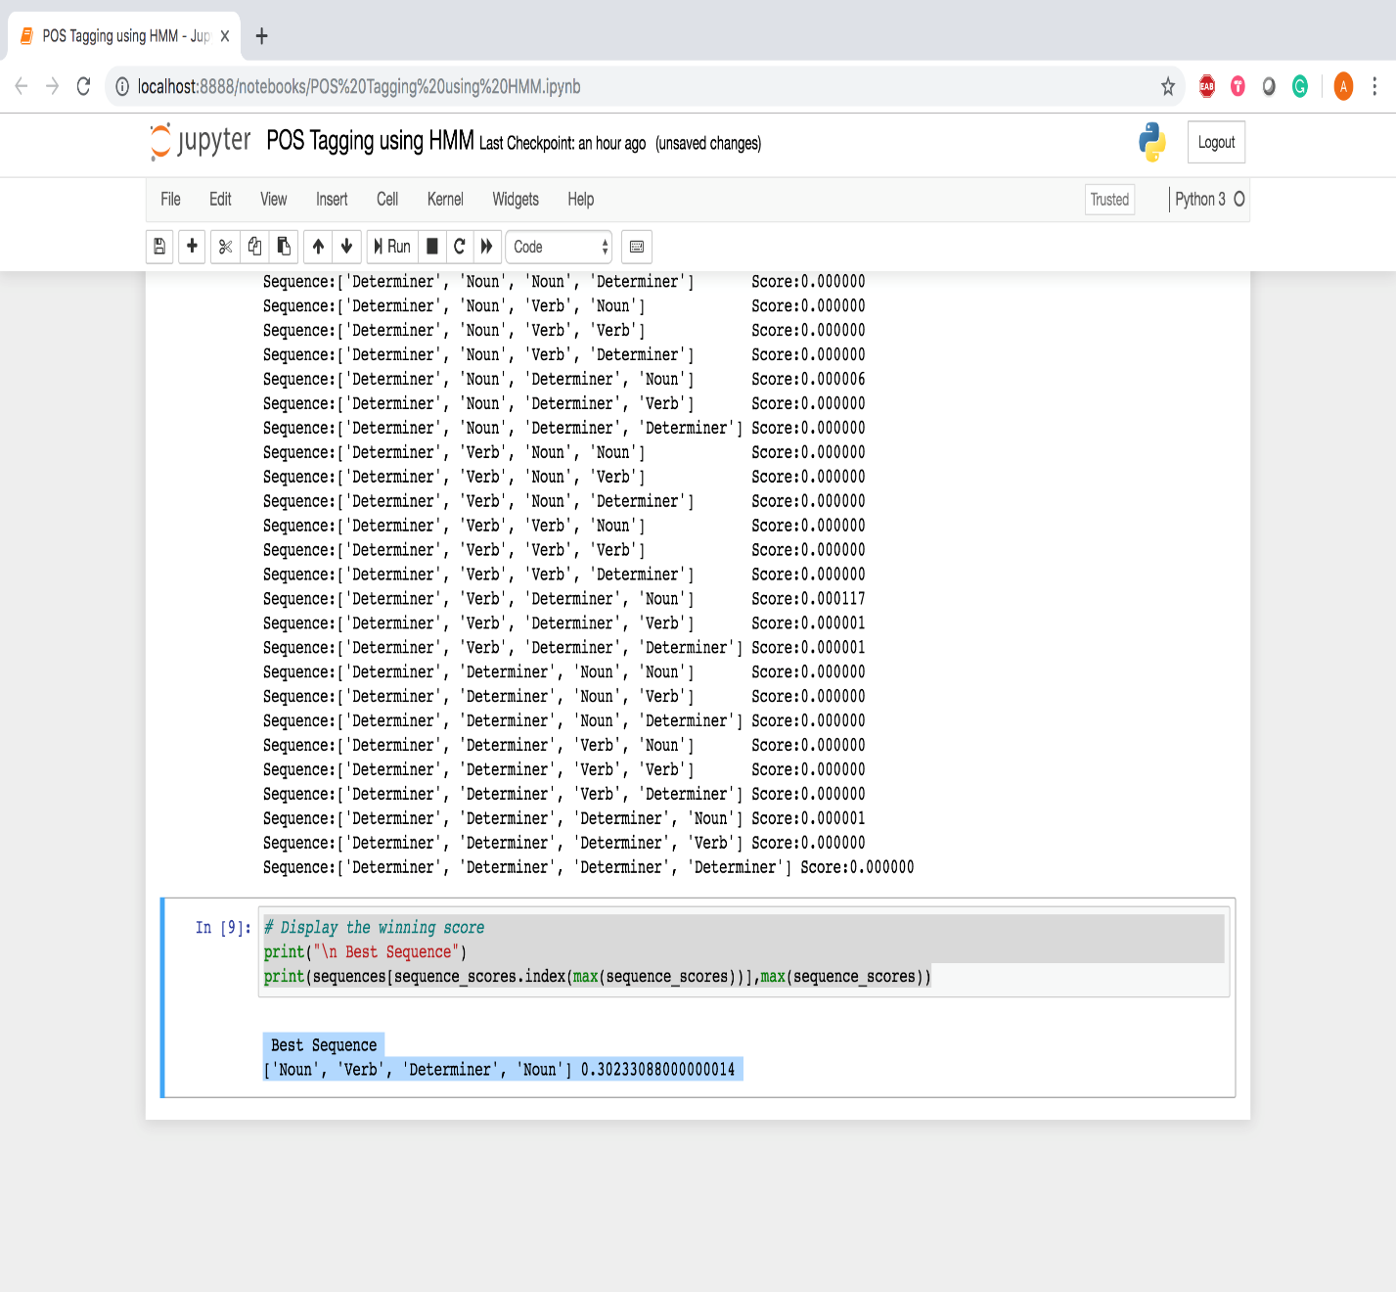

**Lab Exercises**

* Construct the initial , transition and emission probabilities for below corpus of sentences
* Boys are taller.
* This is the tree.
* She is a tall girl.
* Trees are more.
* Girls are more than boys.
* The tall tree is falling.
* Using the above model Predict the PoS tag for the sentence “**Girls are falling**”